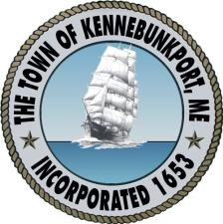

T O W N O F K E N N E B U N K P O R T, M A I N E

~ INCORPORATED 1653 ~

M A I N E ’ S F I N E S T R E S O R T

No Meeting of the Kennebunkport Planning Board
On January 4, 2017 ~ 7:00 PM
Village Fire Station, 32 North Street
AGENDA

THERE WILL BE NO MEETING HELD ON JANUARY 4, 2017. THE NEXT PLANNING BOARD MEETING WILL BE HELD ON JANUARY 18, 2017.

